
Program :B.tech(CSE)
Specialization :AIML
Course Title :AI Assisted Coding
Course Code :24CS002PC215
Semester :3rd semester
Academic Session :2025-2026
Name of Student :BachanagariDeekshitha
Enrollment No. :2403A52032
Batch No. :02
Date :19/08/2025
#LAB ASSIGNMENT
Task Description -1:
Use Gemini and Colab to write a function that filters out all negative numbers from a give list.
#PROMPT:
- Write a python code for a function, out of all negative numbers from the list.
Question:
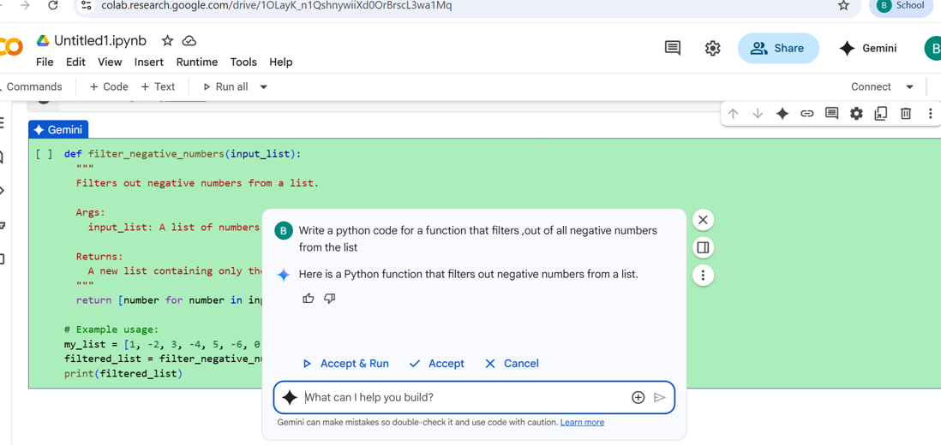
Code:
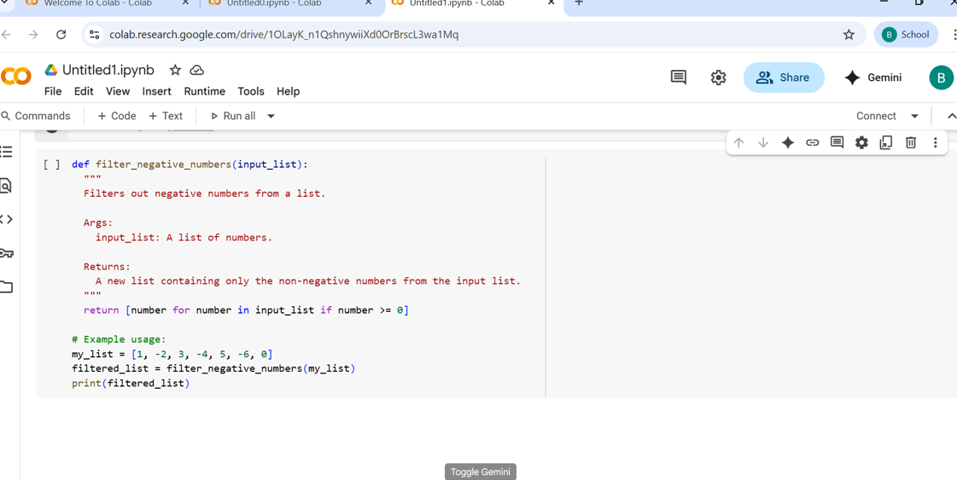
Output:

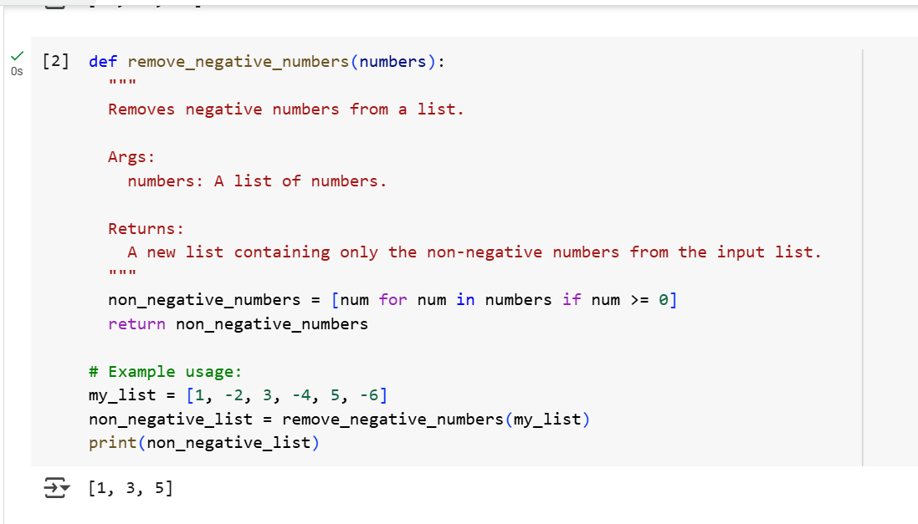

TASK Description-2:
- Ask Gemini to generate code that reads a text file and counts the frequency of each word. Then ask it to explain the code.

#PROMPT:
- Write a python code that reads a text file and count the frequency of each word and explain the code.
Question:
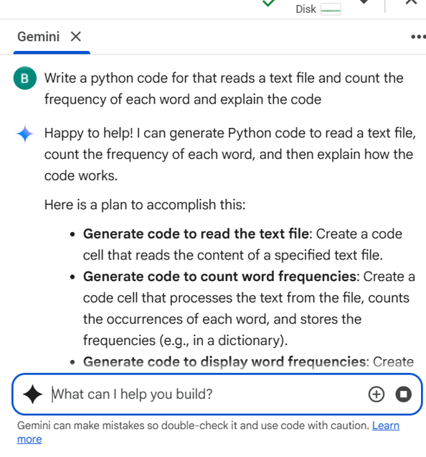
Code:
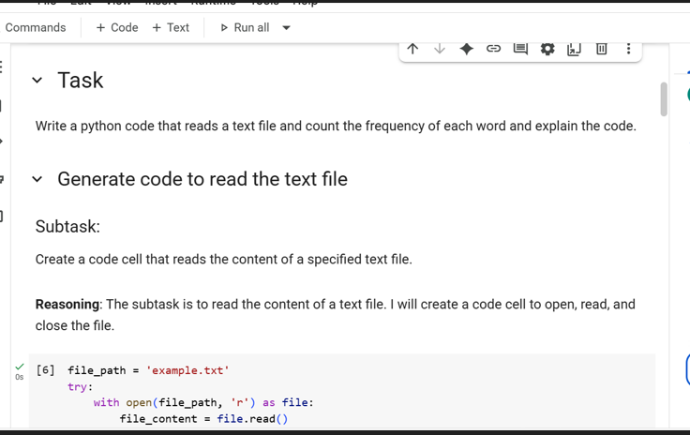
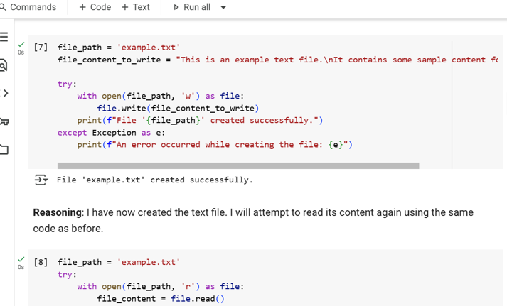
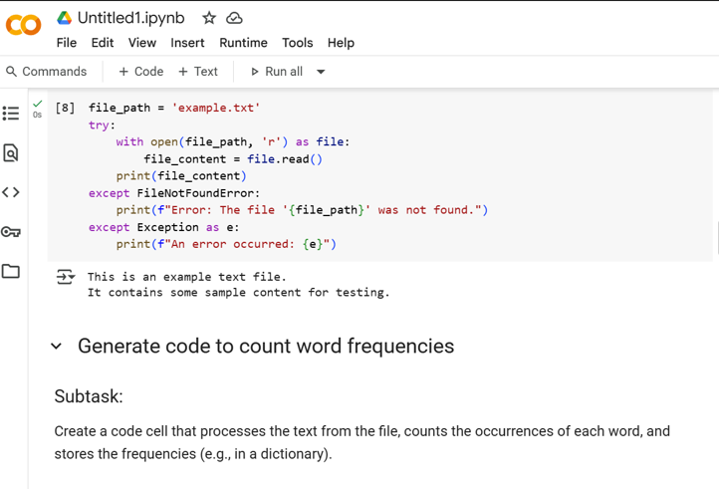
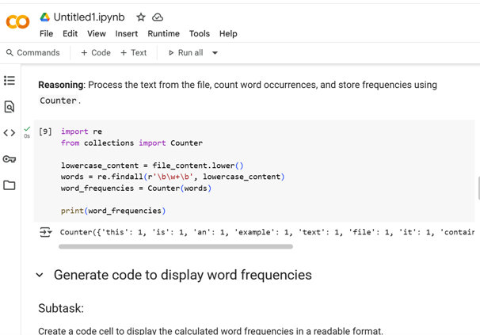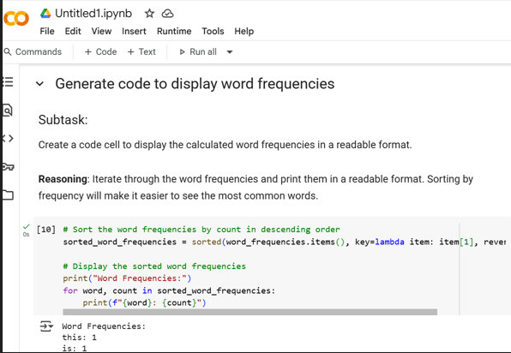
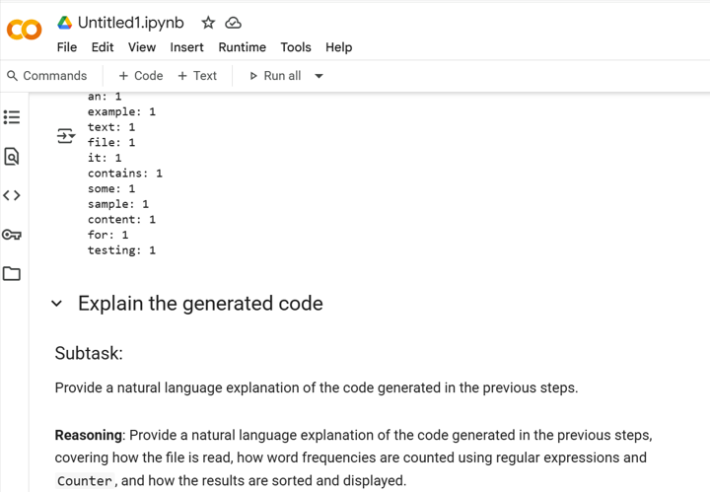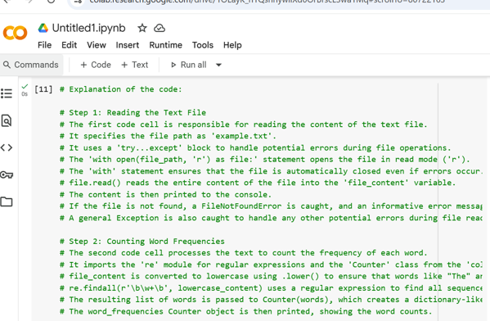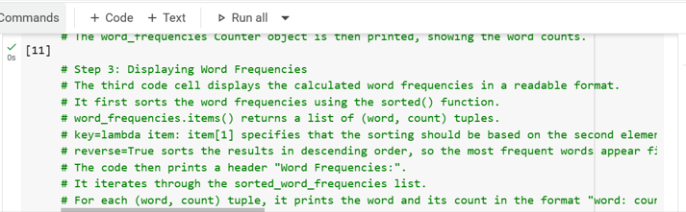

TASK Desciption-3:
- Use Cursor AI to generate a python class called book with attributes title, author, and a method Summery() that prints the details.

#PROMPT:
- Give me a code for python class Book with attributes title, author and a method summery() that prints the details

QUESTION:
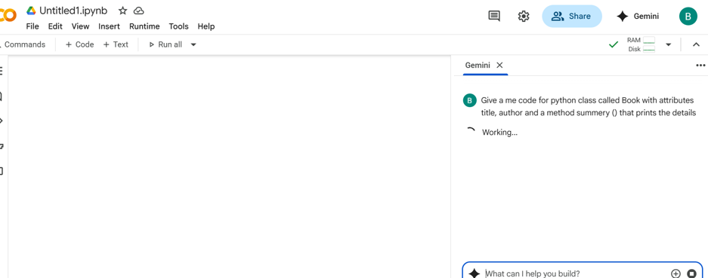

CODE:
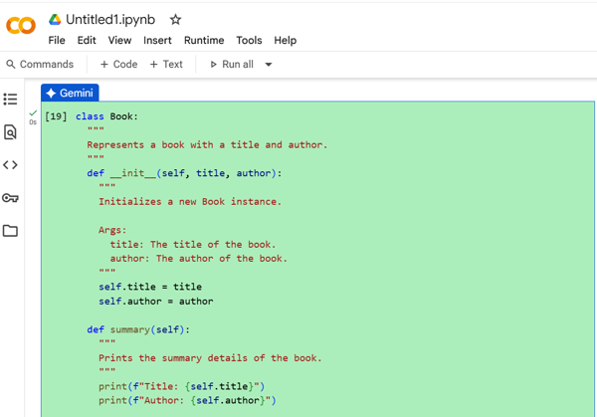
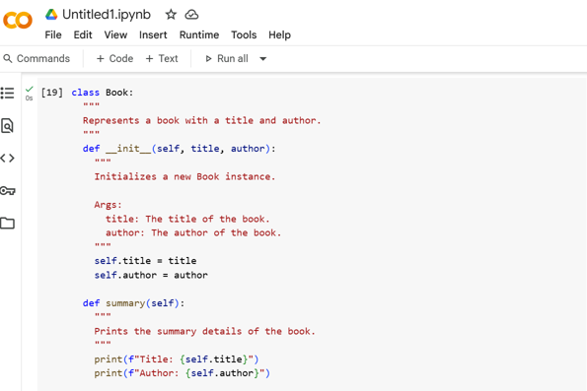

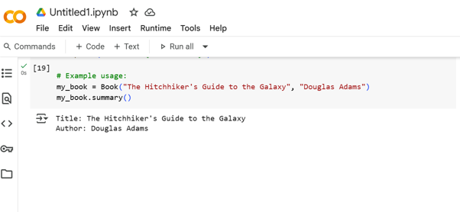

TASK Description-4
- Ask Gemini to write a program that checks whether Number is an Armstrong number ,and then modify using cursor Ai to improve performance or structure.
#PROMPT:
- Write a python to check whether the given number is Armstrong Number, and improve the Structure.

QUESTION:
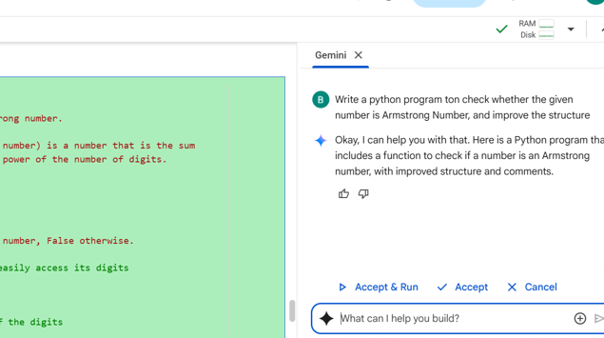

CODE:
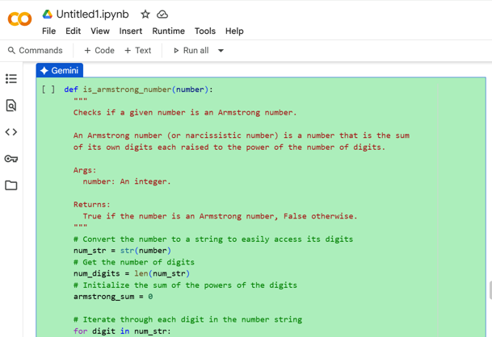
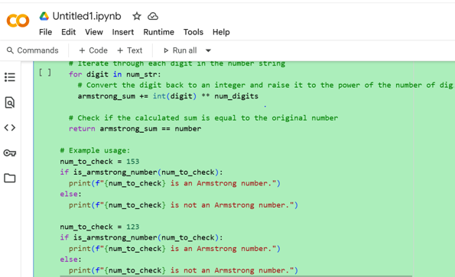
OUTPUT:
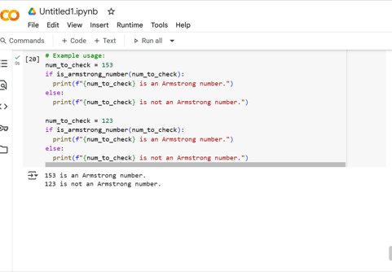
Summery:
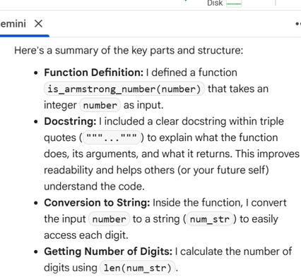
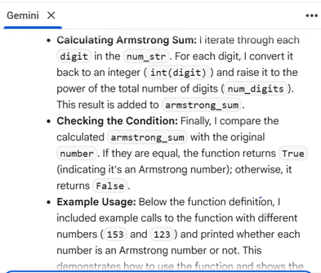
TASK Description-6
- Use both Gemini and Cursor AI to generate code for sorting a list of dictionaries by a specific key (e.g., age).

#PROMPT:
- Write a Python code for sorting a list of dictionaries by a specific key example:age.

QUESTION:
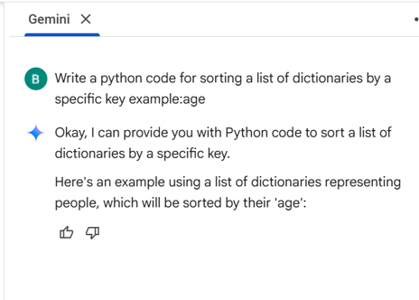
CODE:
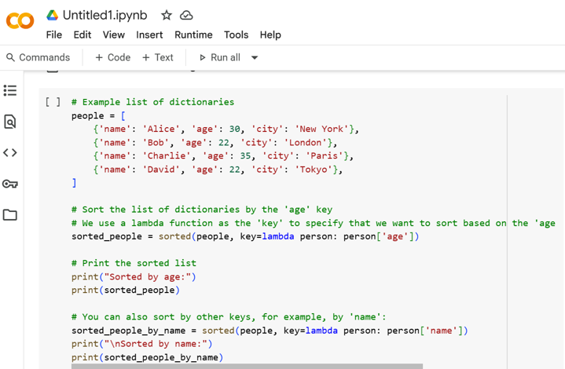
OUTPUT:
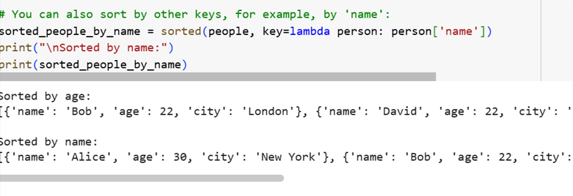
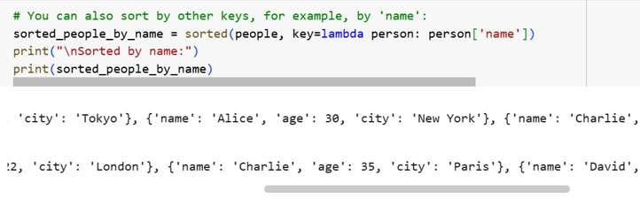
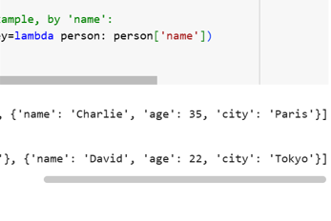

_THANK YOU_

